Response .code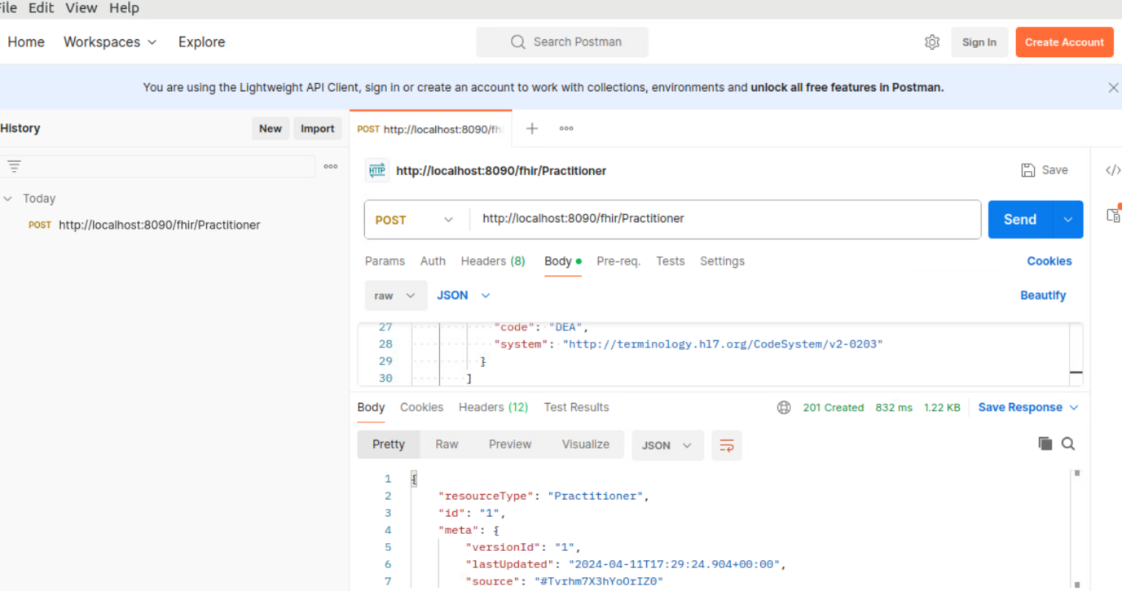

**What is the process to create a new FHIR resource using Postman and HAPI FHIR server**

1. Download Postman, launch it and create a new request

2. Configure Request by setting the request method to POST. Enter the URL of your HAPI FHIR server's endpoint where you want to create the resource and then add necessary headers.

3. Create FHIR Resource by constructing the JSON payload for the FHIR resource you want to create. JSON payload should comply with the FHIR specification and includes all required fields.

4. Send Request to HAPI FHIR server

5.Check the response from the server to see if the resource was created successfully, if not, the server will return appropriate error code together with details in response body

6. You can then verify that the resource was successfully created using a GET request to retrieve the newly created resource.

**What is the process to manage authentication when using Postman with a HAPI FHIR server**

1.Determine Supported Authentication Methods

2. Configure Authentication in Postman by Selecting the appropriate type of authentication from the dropdown menu based on the supported methods identified earlier.

3. Test Authentication credentials and process the request accordingly, if it fails, adjust the credentials as needed.

4. If authentication fails, handle it by Adjusting the authentication credentials or method based on the error details and retry the request.

5. You can then Save Authentication Settings to streamline future requests

**How can you handle error responses from the HAPI FHIR server when using Postman?**

1. Check Response Status Code after sending request to HAPI FHIR server

2. Read Error Response Body if response indicate an error for additional details

3. Interpret Error Details to understand the nature of the errors

4. Take Appropriate Action based on the error details to address the issue

5. Retry the request after addressing the error or Adjust Request based on the details of the error to prevent error from occurring again.